

**Experiment No.: 4**

**Title: Functional Testing using Selenium**

**Batch: B1 Roll No.: 1914078 Experiment No.: 4 Aim:** To perform functional testing using Selenium.

_________________________________ _____________________

**Resources needed:** Internet, Firefox Browser, and Selenium IDE

# Theory:

Selenium is a portable software-testing framework for web applications. Selenium provides a playback (formerly also recording) tool for authoring tests without the need to learn a test scripting language (Selenium IDE). It also provides a test domain-specific language (Selenese) to write tests in a number of popular programming languages, including C#, Groovy, Java, Perl, PHP, Python, Ruby and Scala. The tests can then run against most modern web browsers. Selenium deploys on Windows, Linux, and macOS platforms. It is open-source software, released under the Apache 2.0 license. Web developers can download and use it without charge.

**Selenium IDE** is an integrated development environment for Selenium scripts. It is implemented as a Firefox extension, and allows you to record, edit, and debug tests. Selenium IDE includes the entire Selenium Core, allowing you to easily and quickly record and play back tests in the actual environment that they will run in.

Selenium IDE is not only a recording tool: it is a complete IDE. You can choose to use its recording capability, or you may edit your scripts by hand. With auto complete support and the ability to move commands around quickly, Selenium IDE is the ideal environment for creating Selenium tests no matter what style of tests you prefer.

# Features:

* Easy record and playback
* Intelligent field selection will use IDs, names, or XPath as needed
* Autocomplete for all common Selenium commands
* Walk through tests
* Debug and set breakpoints
* Save tests as HTML, Ruby scripts, or any other format
* Support for Selenium user-extensions.js file
* Option to automatically assert the title of every page

# __________________________________________________________________________ Procedure:

1. **Install Selenium IDE.**

**Step1-**Launch Firefox and navigate t[o https://addons.mozilla.org/en-](https://addons.mozilla.org/en-US/firefox/addon/selenium-ide/) [US/firefox/addon/selenium-ide/.](https://addons.mozilla.org/en-US/firefox/addon/selenium-ide/) Click on Add to Firefox.

**Step2 -** Click on Add Button to Give Permission.

**Step3 - Launch Selenium IDE** Click on Selenium Icon appear on the right hand side of the address bar.



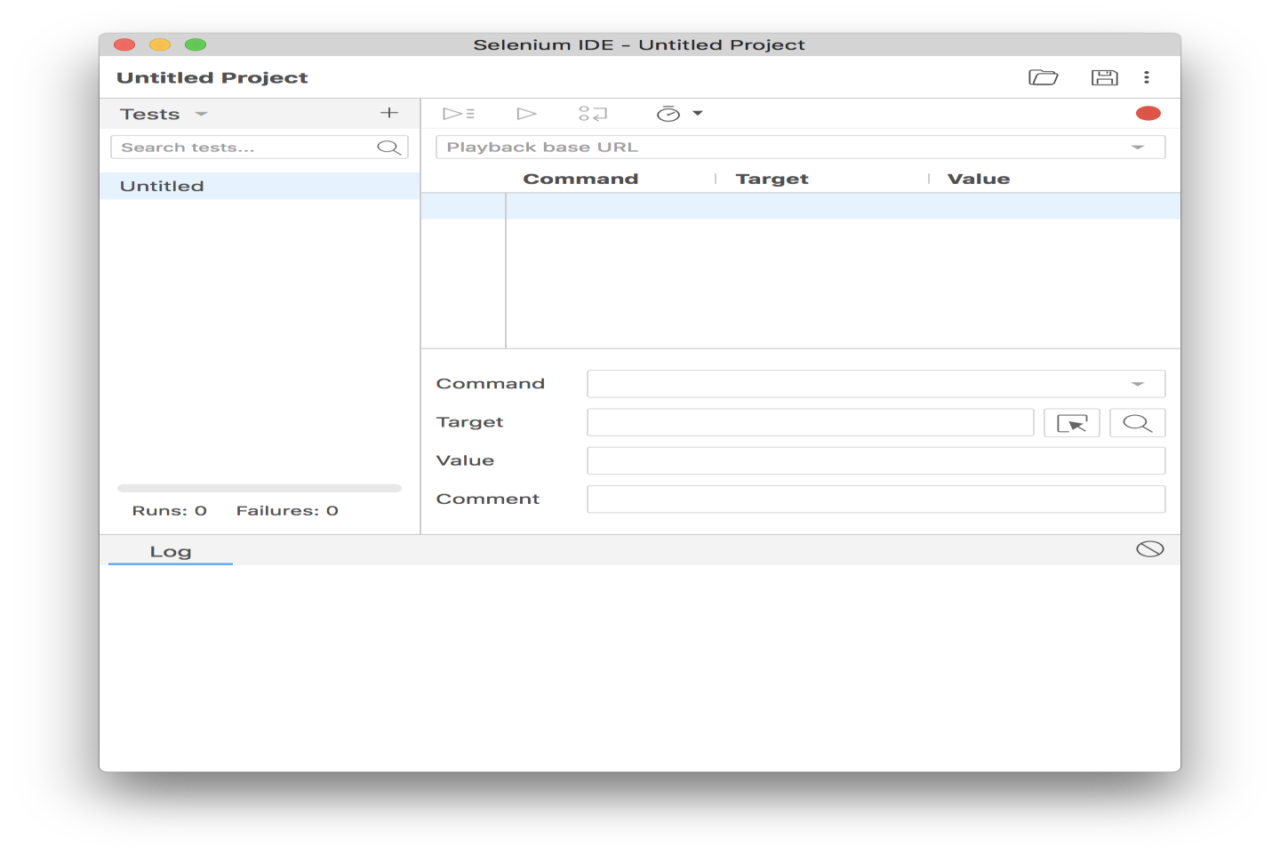

1. **Open any Website (under test) on Firefox** – For example:<http://automationpractice.com/index.php>

# Document and Implement the following Features:

* 1. Auto Scripting and Playback
  2. Verification
  3. Assertion
  4. Store Variables

**Note** :**Since Selenium IDE is Firefox based extension we need to Install Firefox** [**https://www.mozilla.org/en-US/firefox/57.0/releasenotes**](https://www.mozilla.org/en-US/firefox/57.0/releasenotes/)**/**

**Results:**

1. Downloading Selenium extension and adding it to chrome

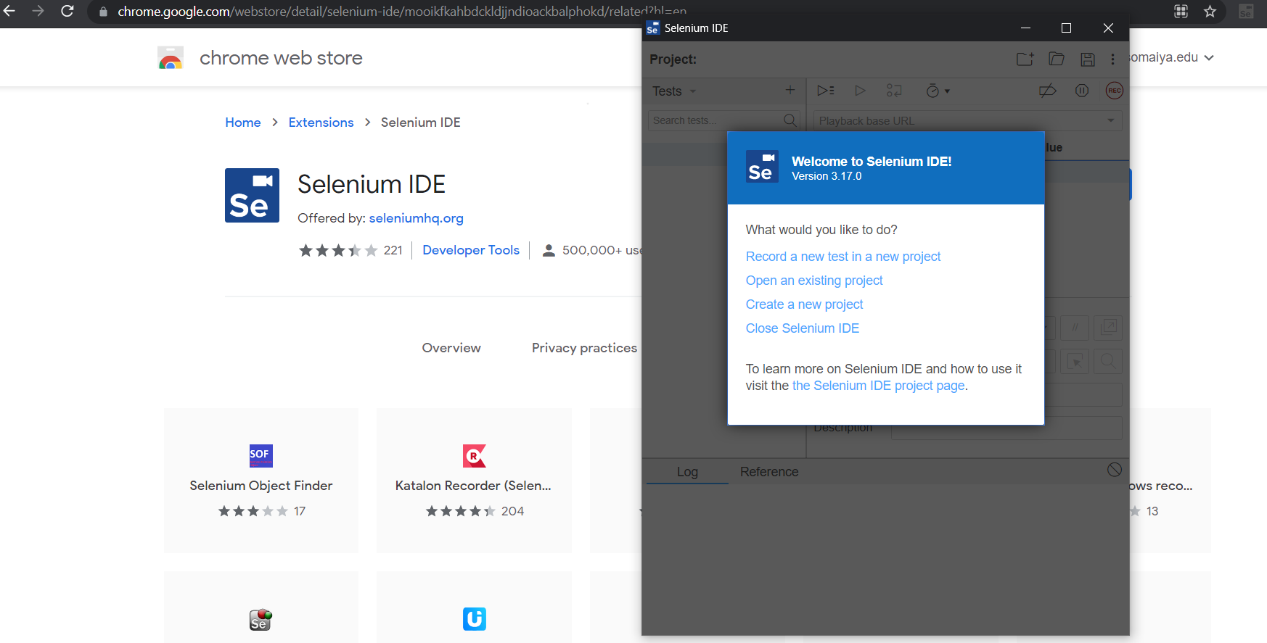

1. Creating a project on selenium named STQA_Exp_4.

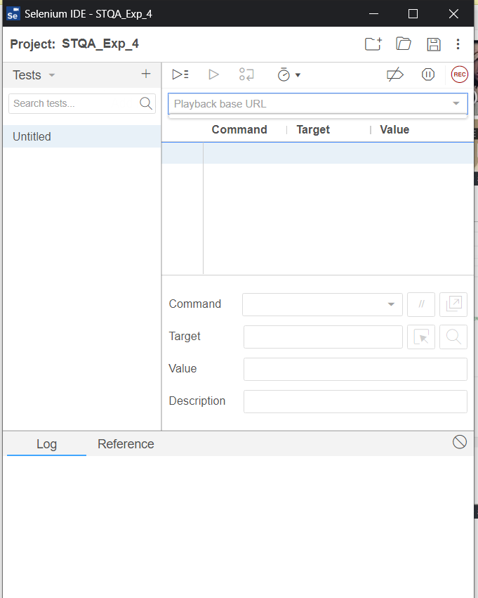

1. Website to be tested

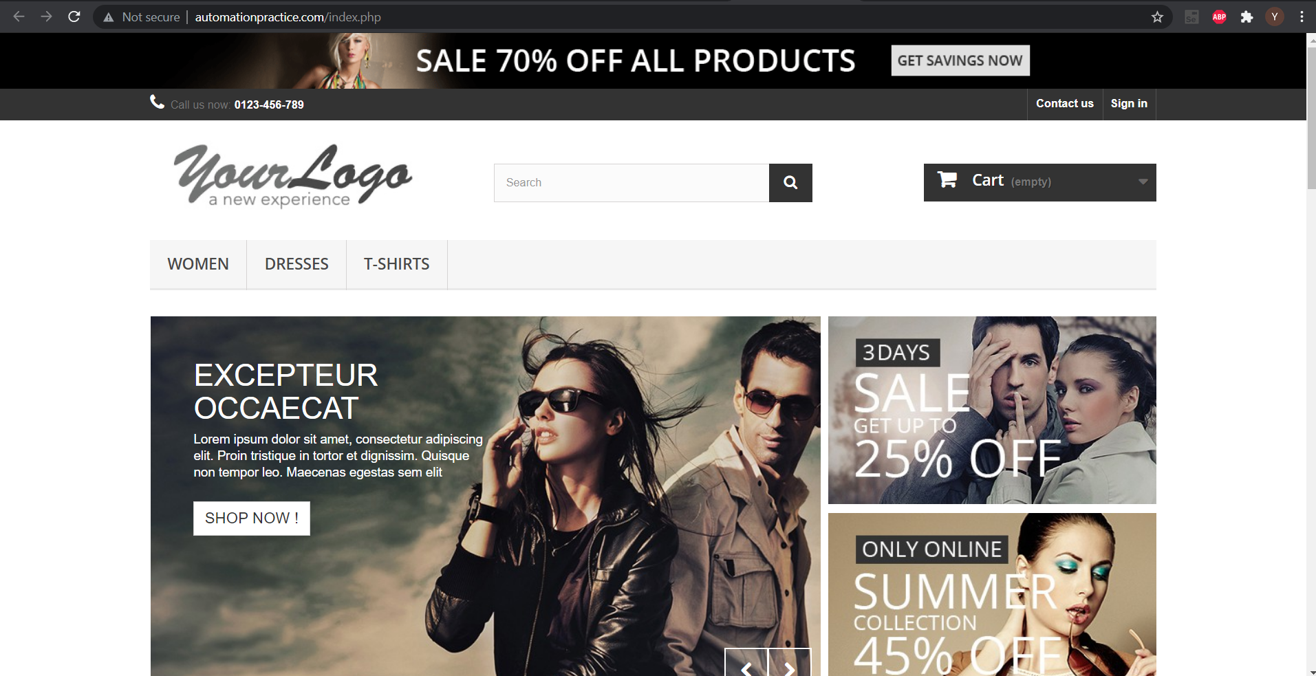

1. Creating a new test.

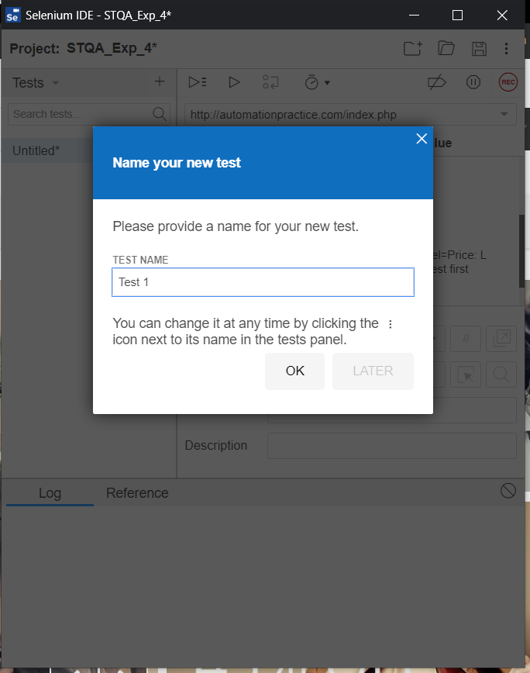

6. Recording and playback of test 1.

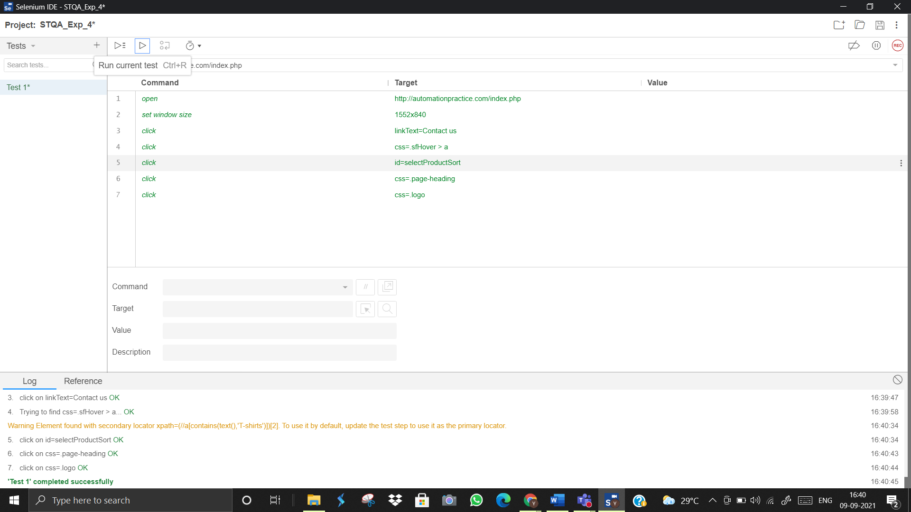

6. Recording and playback of test 2.

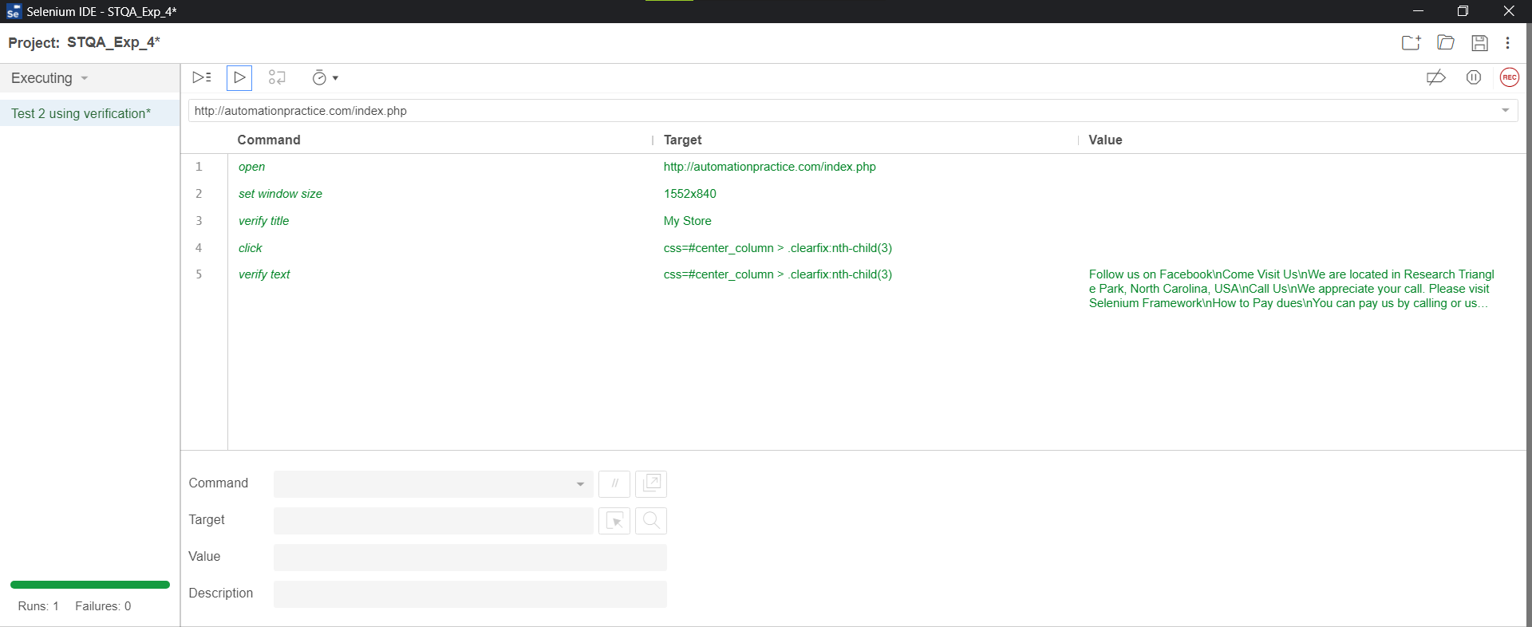

7. Creating a new Test case Named Test 2

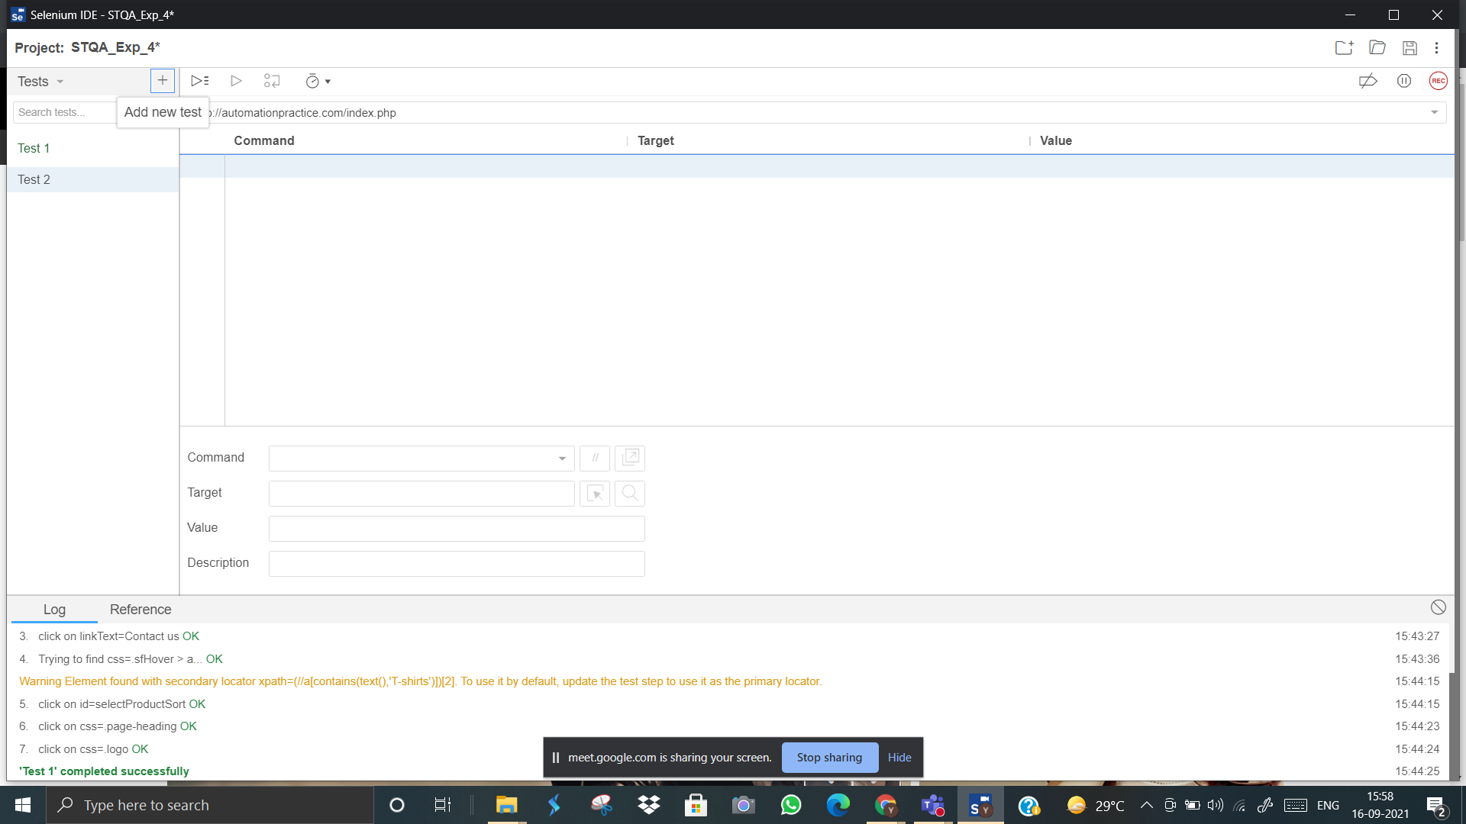

**Verification :**

8. Creating manual the test case for verification

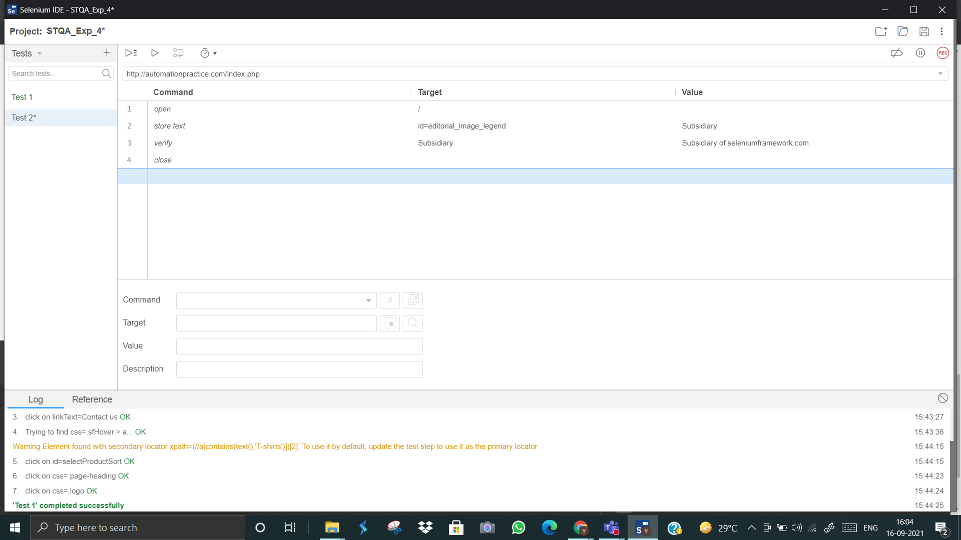

9. Running the test case and verifying it

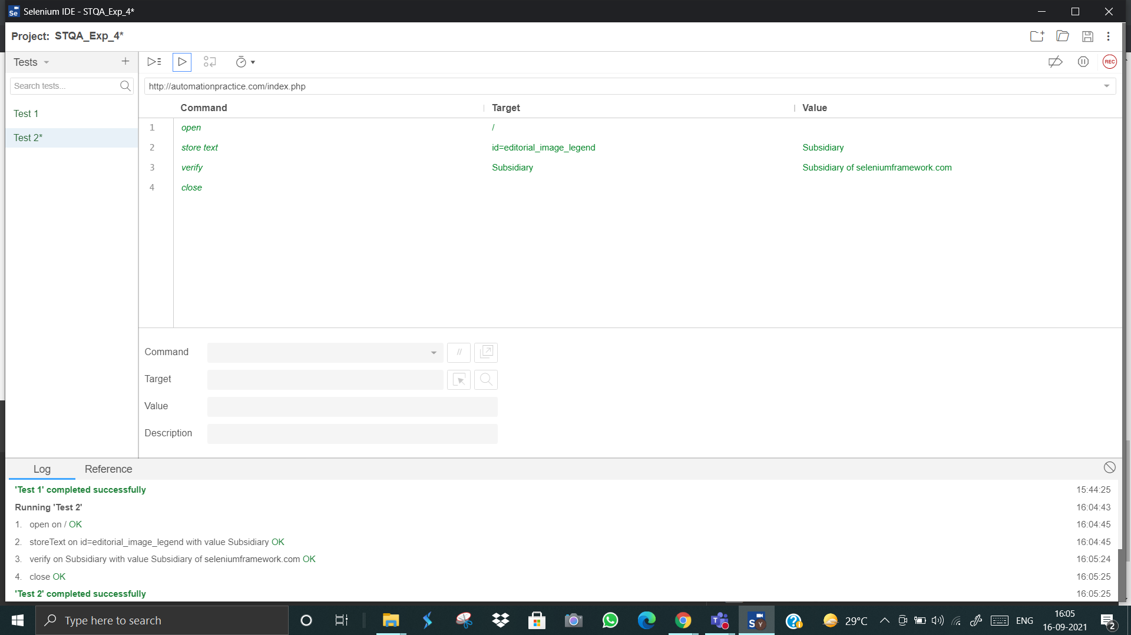

**-> Verification of the element is a SUCCESS**

10. Entering the wrong value for a failure

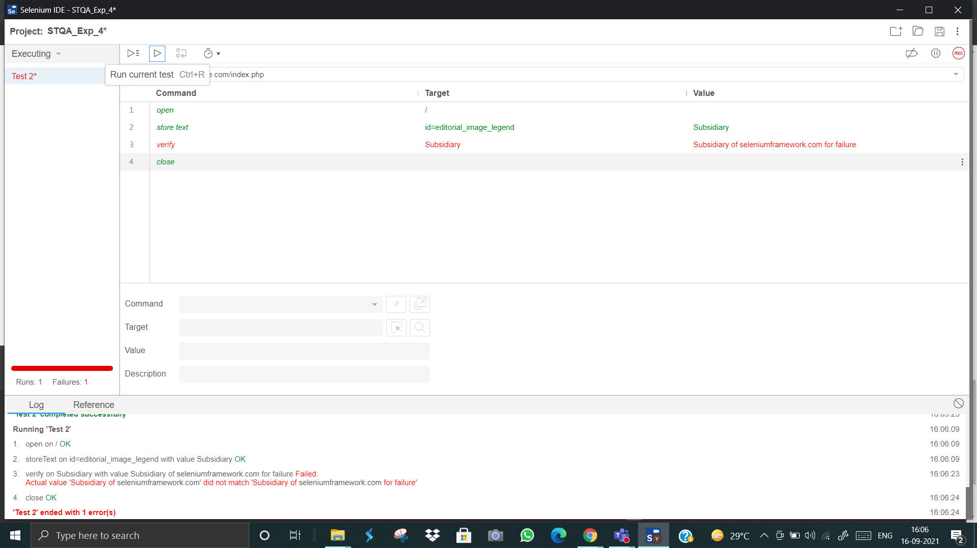

**-> Verification of the element is a FAILURE.**

**Assertion :**

11. Creating a test case for named TEST 3 for assertiton

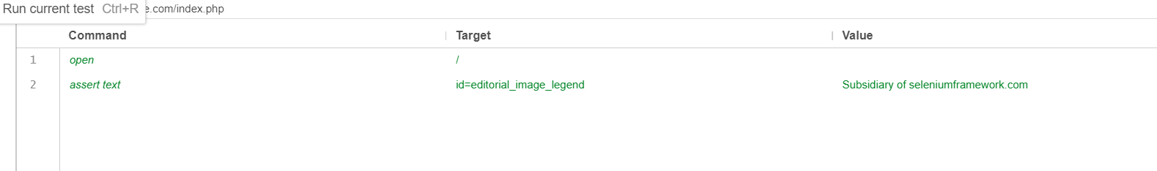

12. Running the test case

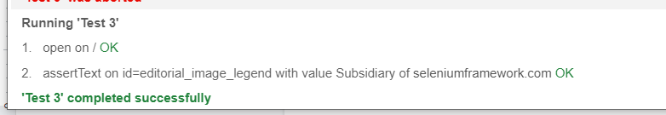

**-> Assertion of the element is success**

13. Entering wrong value for failure

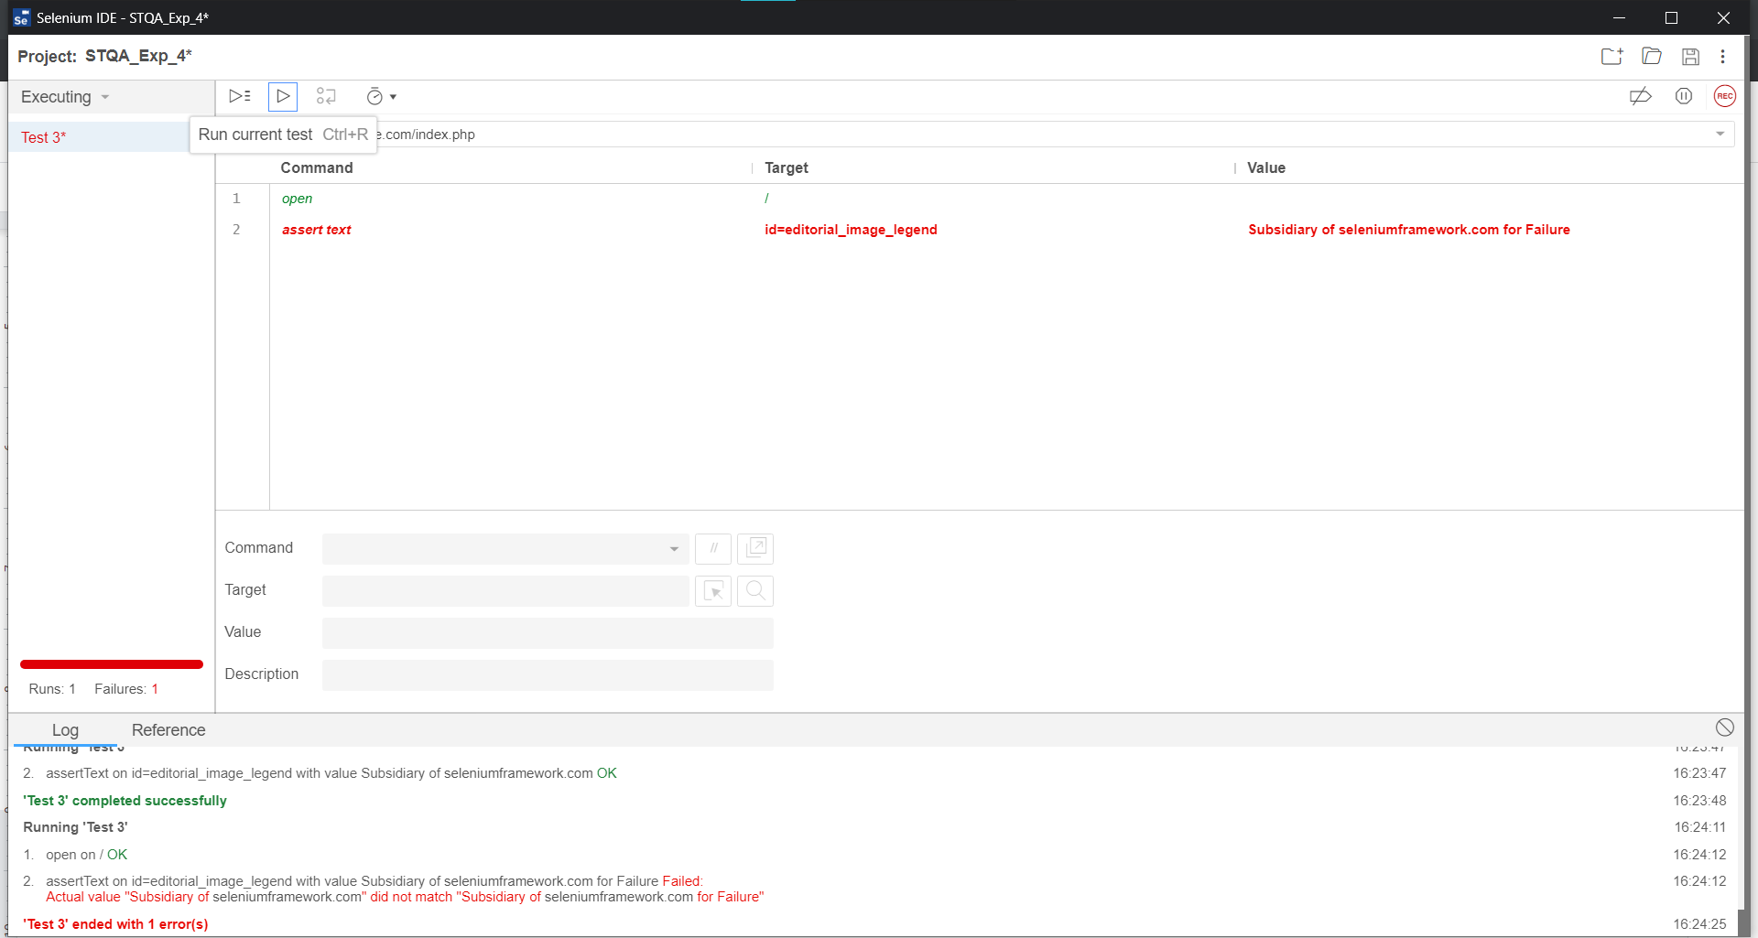

**-> Assertion of the element is failure**

**Storing variables**

14. Creating a new test case named test 4 for storing the value entered value in search bar

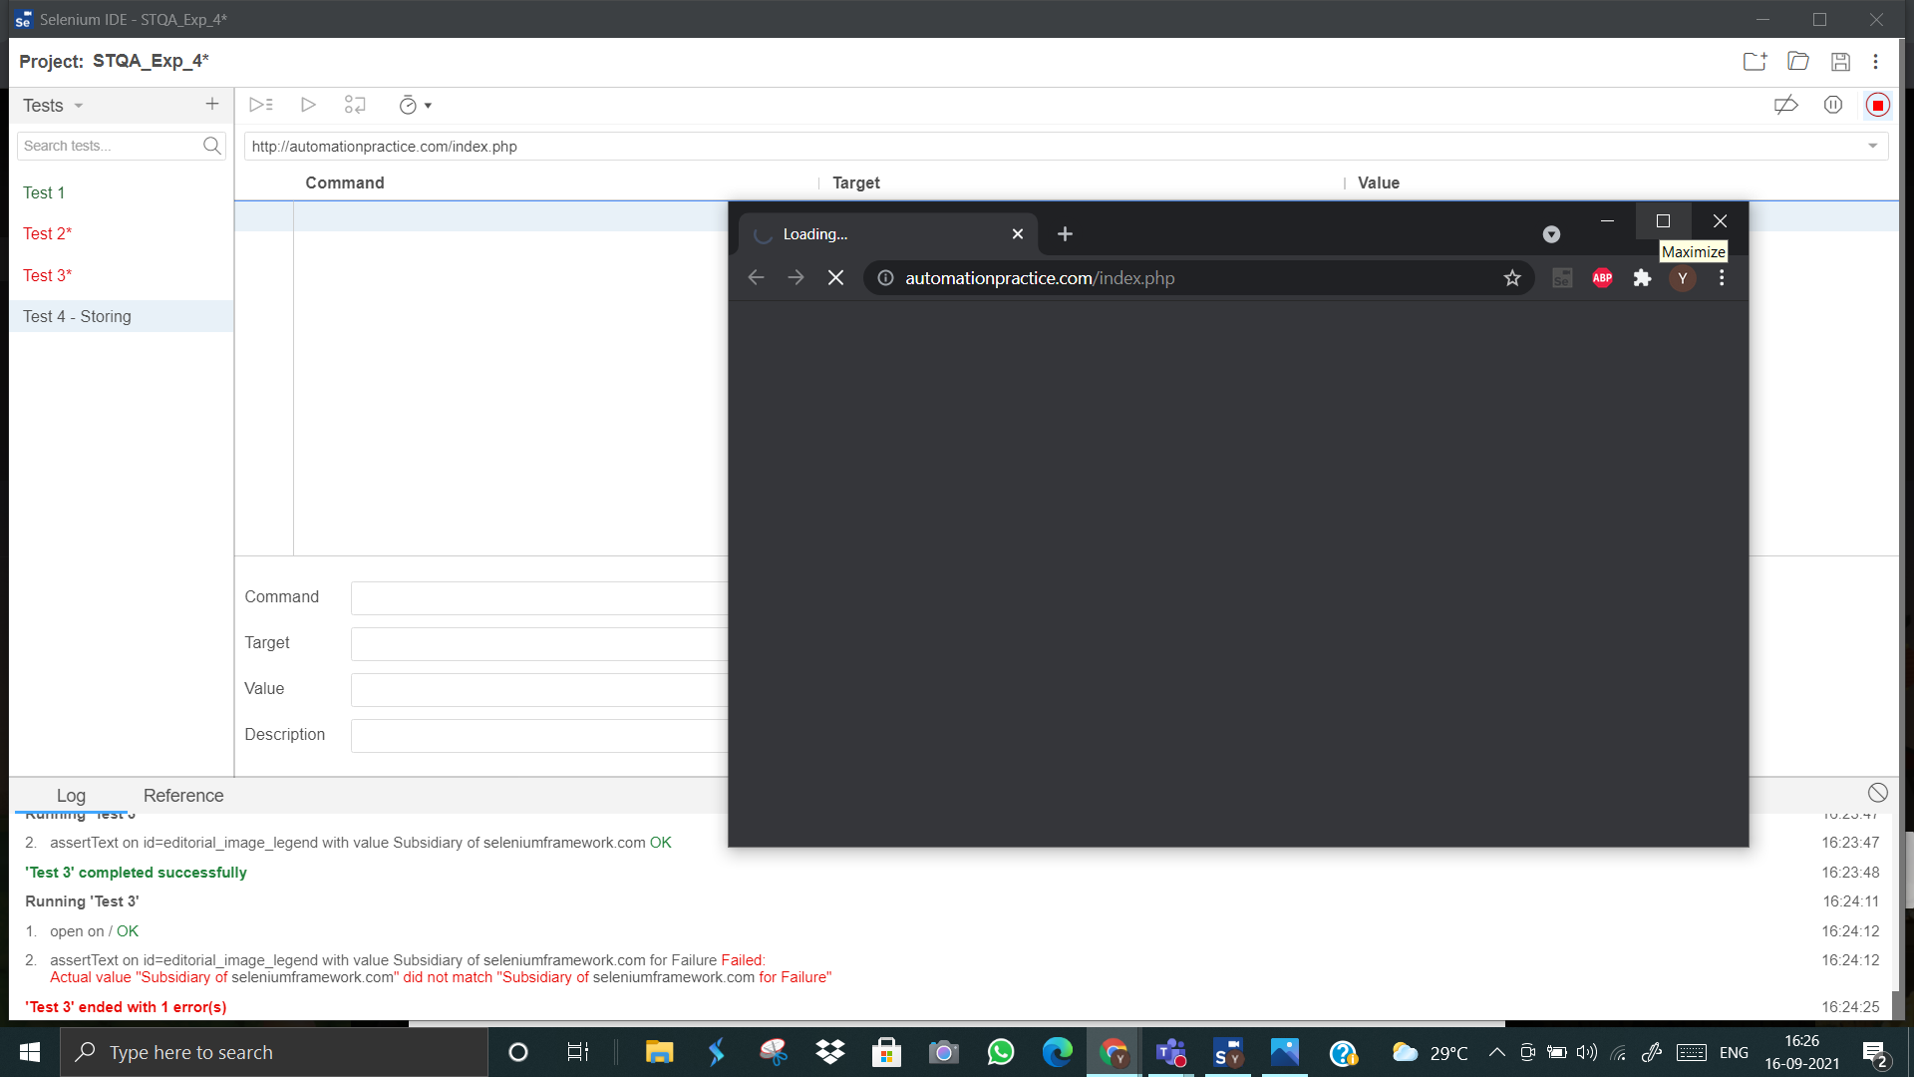

15. Recording the entered text in search box in a variable named “search_text”

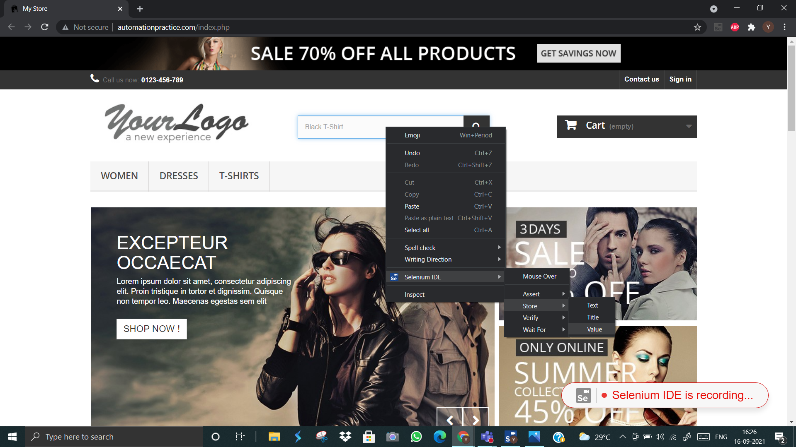

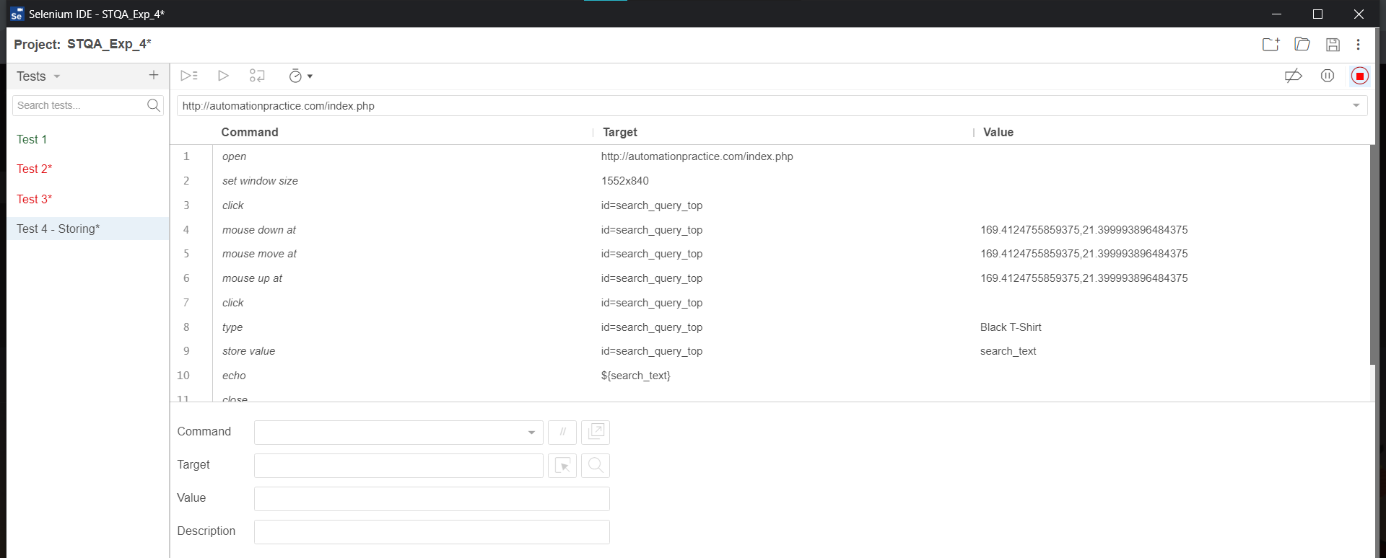

16. Playback the test case.

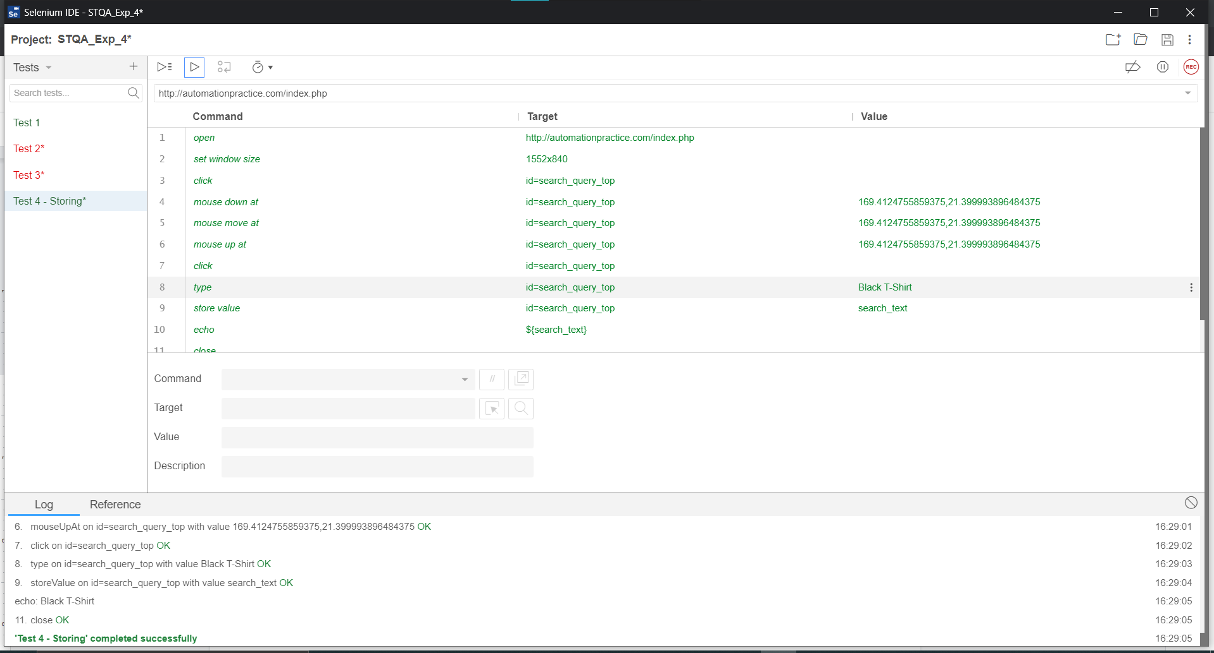

**-> Test Case is a SUCCESS.**

Echoing the value of the stored variable

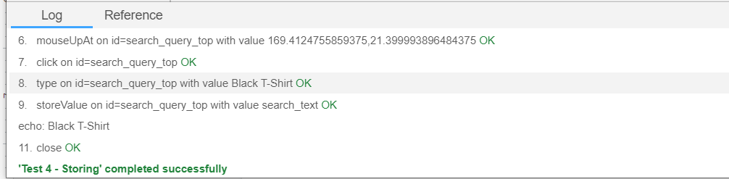

# Questions:

1. **Explore one additional feature of Selenium not listed in the write up. Document and implement it.**

**Ans:** Text execution speed- The purpose of the set speed command is to modify the default speed of Selenium IDE execution (i.e., 0 seconds) to the required milliseconds. The purpose of the set speed command is to modify the default speed of Selenium IDE execution (i.e., 0 seconds) to the required milliseconds.

Initially we kept the speed of execution fast and performed the test and then we changed the execution speed and repeated the steps, thus from the screenshots attached below we can see the execution time difference.

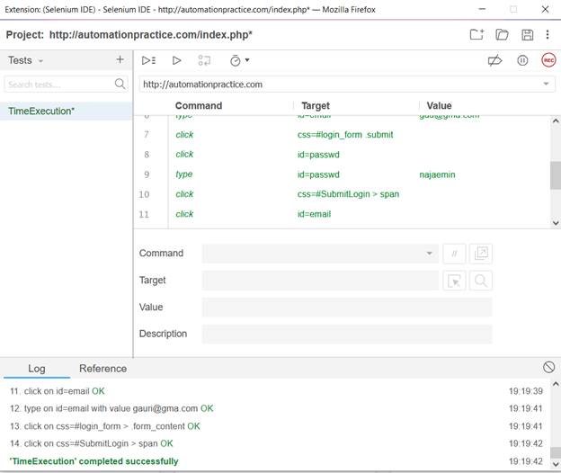

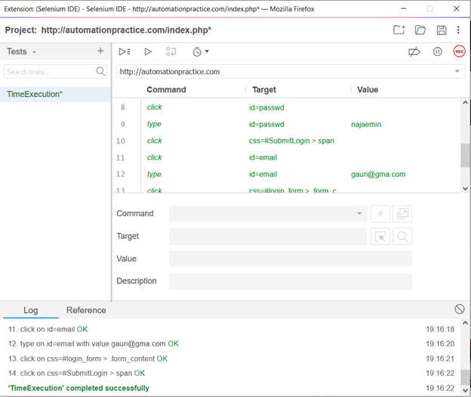

**Outcomes:** C03 - Apply recent automation tools for testing software.

**_______________________________________________________________________________ Conclusion: (Conclusion to be based on outcomes)**

We learned about Selenium IDE basics and features and tested, asserted and verified features of a testing website using Selenium IDE in Chrome.

**Grade: AA / AB / BB / BC / CC / CD /DD**

**Signature of faculty in-charge with date**

**_____________________________________________________________________________ Reference Websites:**

* 1. https://[www.seleniumhq.org/docs/02_selenium_](http://www.seleniumhq.org/docs/02_selenium_) ide.jsp
  2. https://[www.guru99.com/se](http://www.guru99.com/se)lenium-tutorial.html
  3. <http://demo.guru99.com/test/newtours/index.php>
  4. <https://phptravels.com/demo/>
  5. <http://automationpractice.com/index.php>